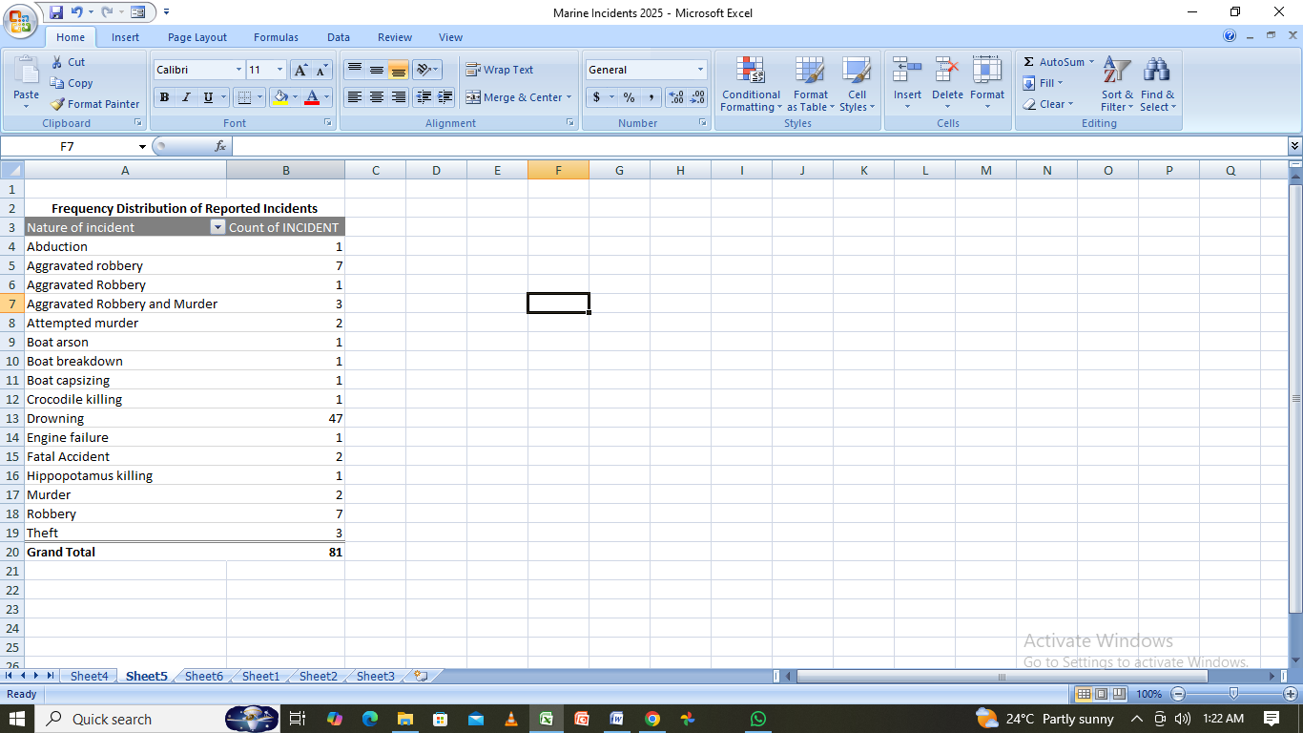
Major Types of Incidents
The most frequently reported incident is drowning, followed by robberies.
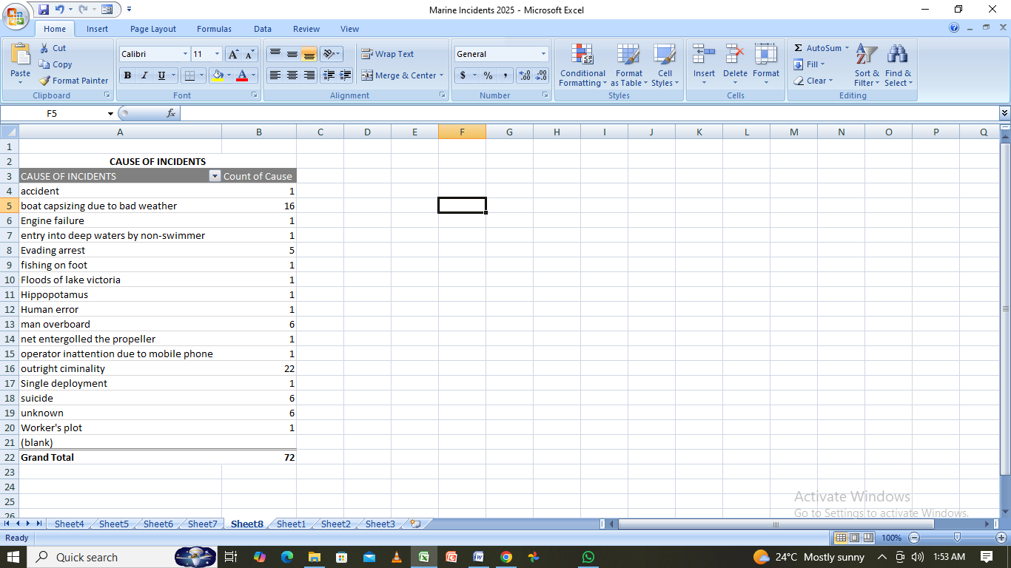
Outright criminaality is the major cause of incidents followed by bad weather.
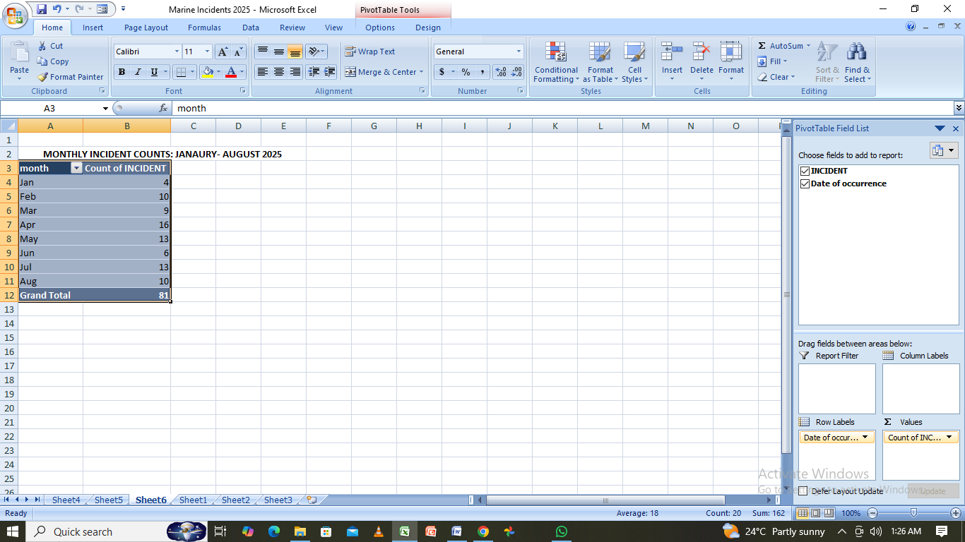
The month of April registered more incidents followed by july.

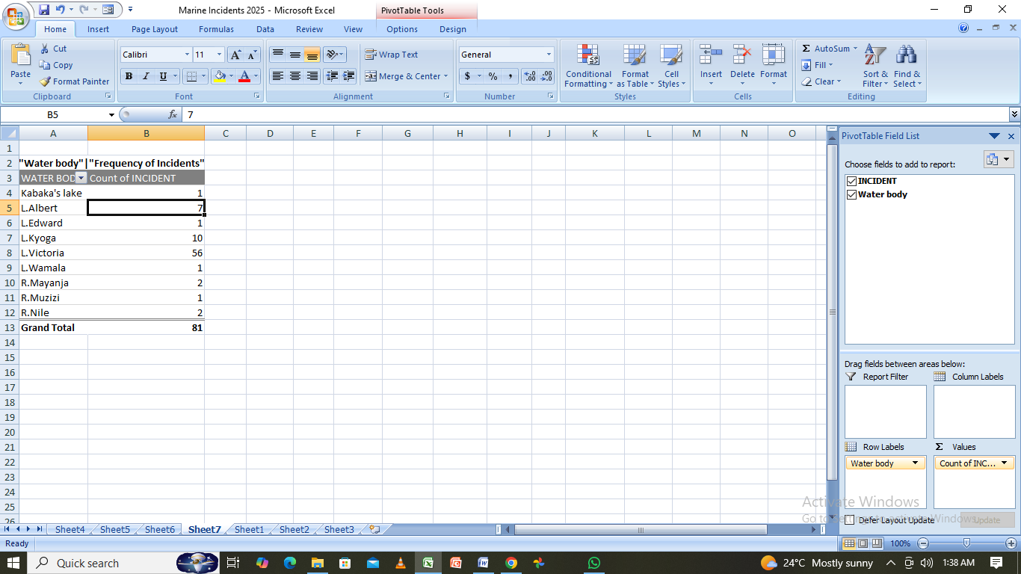
Most cases occur at lake Victoria followed by lake kyoga then lake Albert.
SUMMARY POINTS
1. Incident Overview
- Total reported incidents: 81.
- Monthly trend shows a slight increase in mid-year, peaking in April and July.
2. Locations of Concern
- Most incidents occurred at Lake Victoria, followed by Lake Kyoga, then Lake Albert.

3. Nature of Incidents
- Drowning is the leading type of incident.
- Other incidents include Robberies.
4. Safety Measures Taken
- Mandatory life jackets for all passengers.
- Regular inspections and monitoring of vessels.
- Average emergency response time: 25 minutes.
- Ongoing public awareness campaigns on water safety e.g radio talk shows, community policing forums.
5. Key Public Messages
- Wear a life jacket at all times.
- Avoid travel during poor weather conditions.
- Do not overload vessels.
- Report unsafe practices immediately.
- For emergencies, call the Marine Emergency Hotline: 0800300113
- Be alert for suspicious groups.

